**Freeze dryer**

Contact Dr. Yvonne Sawall

[yvonne.sawall@bios.asu.edu](mailto:yvonne.sawall@bios.asu.edu)

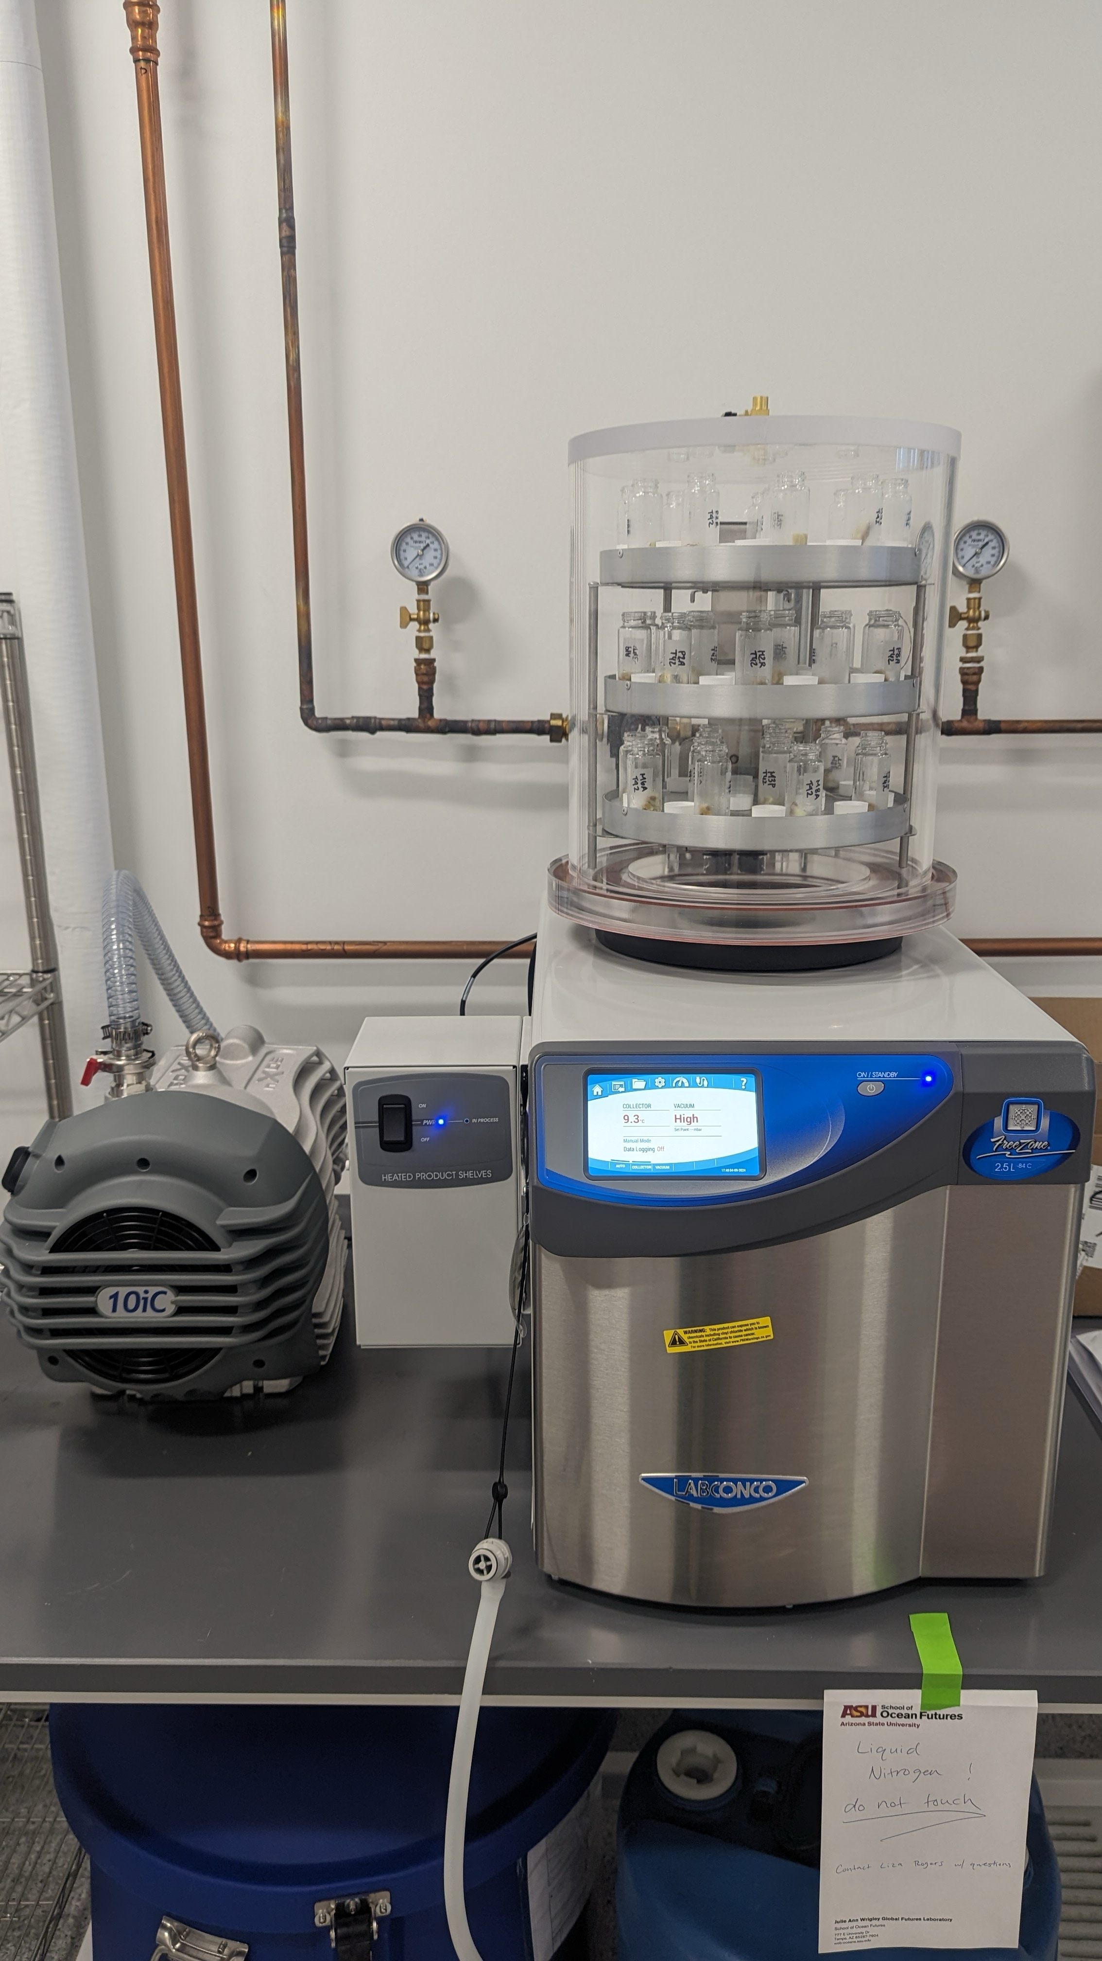

Empty the water reserve by connecting the quick-connect drain on the bottom left of the freeze-dryer. Use the big blue barrel to collect the water. If there is water, it will run directly when connecting the drain. Disconnect the drain afterward or the freeze dryer will not run.

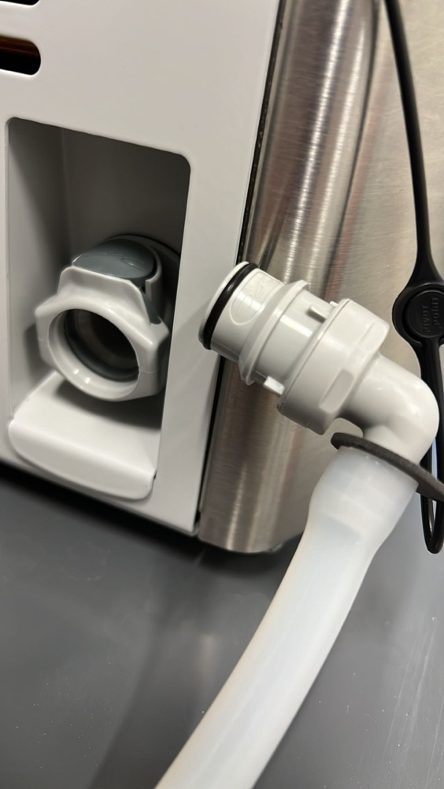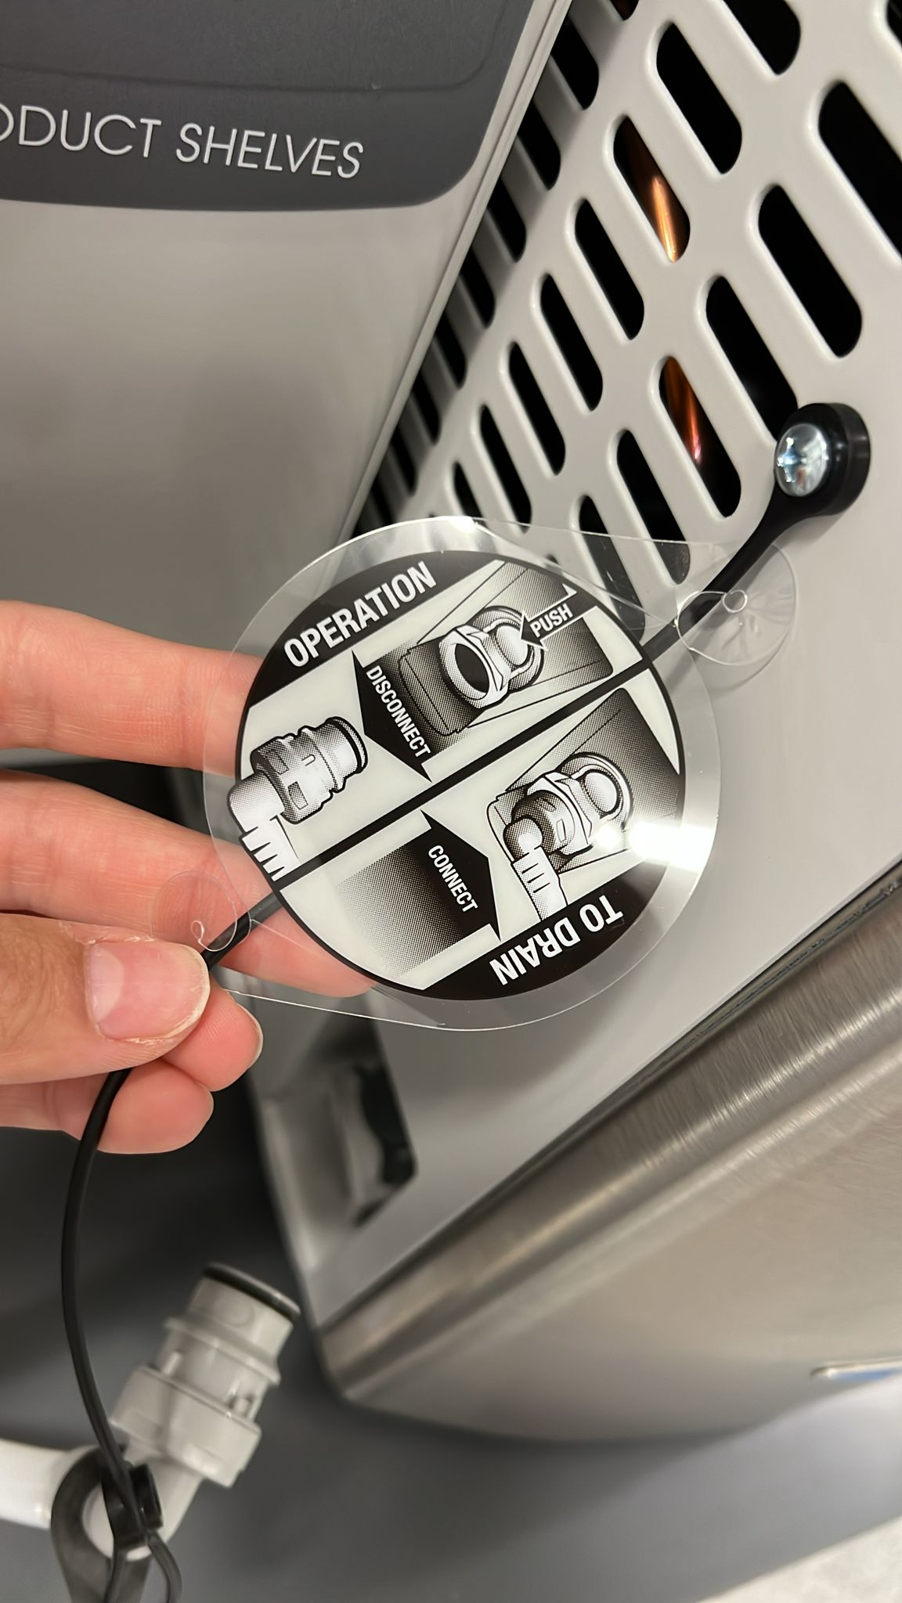

Turn on the main freeze dryer machine and the control assembly on the left next to it

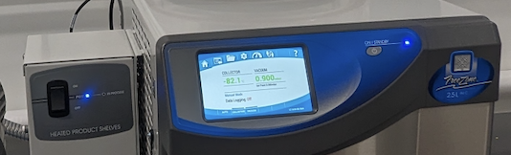

Turn on the refrigeration system on the freeze dryer by clicking on “AUTO” and allow it to come to operating temperature, -80°C, it takes ~15 min

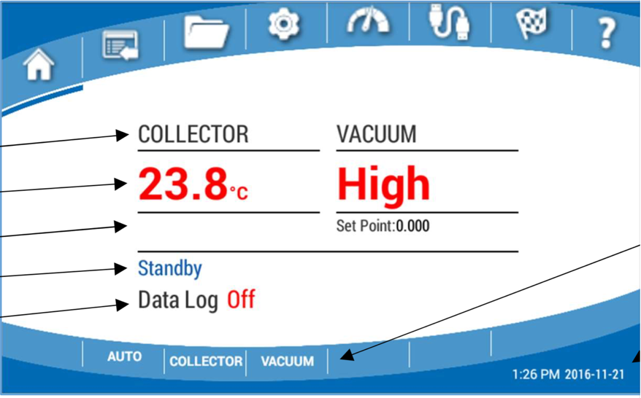

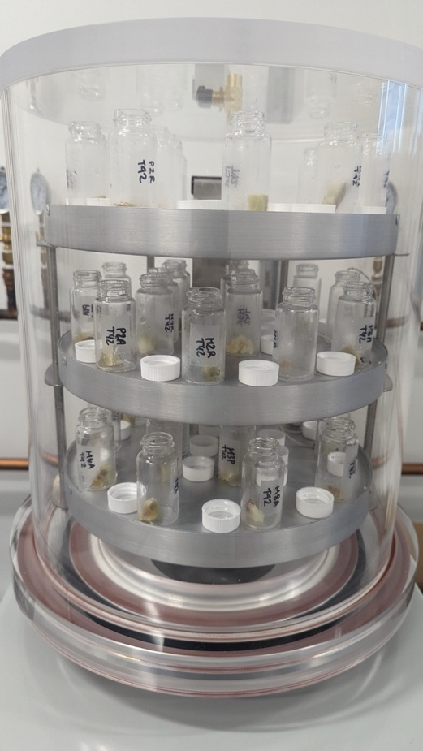**Make sure that your samples are frozen before using the freeze-dryer**.

Remove the collector plexiglass chamber lid

Clean the chamber with KimWipes and milliQ water. No chemicals.

Place the pre-frozen samples opened (vials without a tap) inside the clear chamber

Make sure that the temperature probes tip (3 little wires with metal tip) are touching each shelf of the chamber

Check all the rubber seals on the base and gasket assembly to spot any deterioration or dust, it would avoid a good seal during vacuum.

Put the collector chamber lid back. Make sure the vent valve on top is closed

Turn on the vacuum pump by pushing the green button when the light turns on next to the buttons on the left of the vacuum pump.

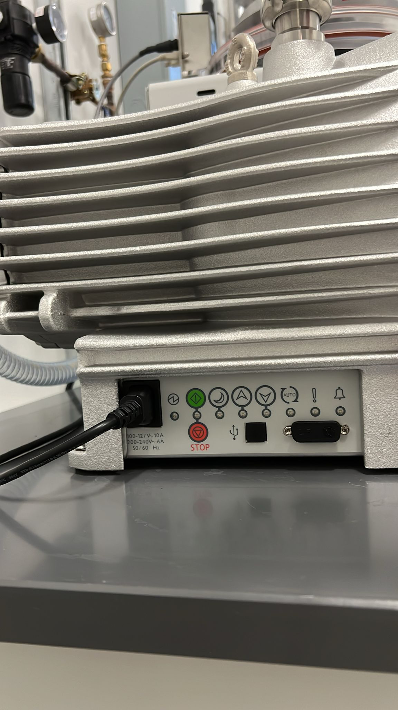

Once the samples are completely dry, usually after drying over night, turn off the vacuum pump by pushing the red button. Open the vent valve on top of the lid chamber. When the vacuum bleeds from the chamber, the plexiglass lid may be removed.

Turn off the “AUTO”, “COLLECTOR” and/or “VACCUM” programs



Take your samples out. Clean the shelves and empty the water inside the freeze-dryer using the drain. Don’t forget to disconnect the drain afterward.

Turn off the main freeze dryer machine and the control assembly on the left